**Ideation Phase**

**Empathize & Discover**

|  |  |
| --- | --- |
| Date | 28 June 2025 |
| Team ID | LTVIP2025TMID49827 |
| Project Name | **Heritage Treasures: An In-Depth Analysis of UNESCO World Heritage Sites in Tableau** |
| Maximum Marks | 4 Marks |

**Empathy Map Canvas:**

This project explores global UNESCO World Heritage Sites using data visualization.  
It identifies endangered sites and analyzes patterns by region, type, and area.  
The goal is to support informed preservation strategies through insights.  
Stakeholders include conservationists, policymakers, and cultural organizations.  
Tableau dashboards present interactive views of heritage site trends.  
This empowers better planning to protect humanity’s cultural and natural treasures.

**Example:**

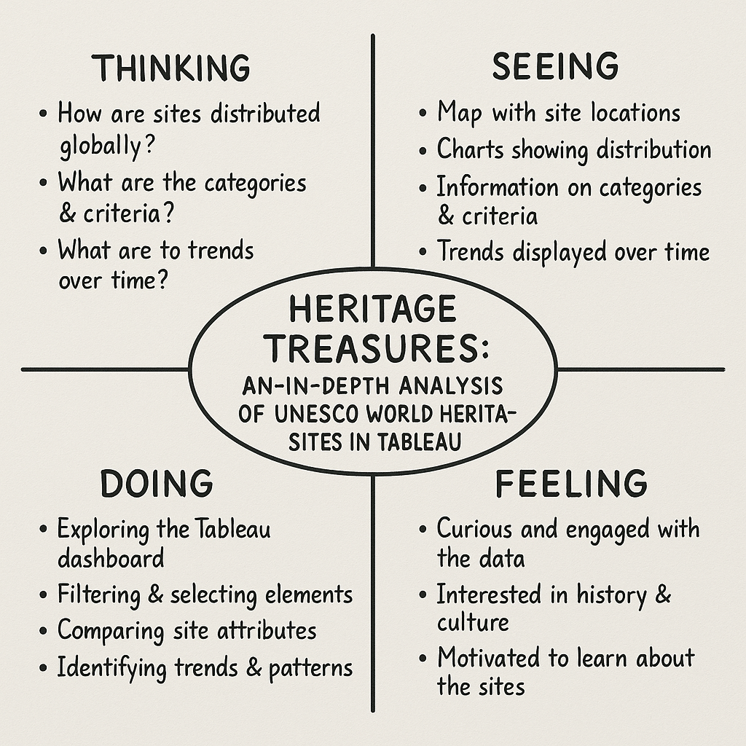

Reference: <https://www.mural.co/templates/empathy-map-canvas>

**Example: Food Ordering & Delivery Application**

